

### [VISVESVARAYA TECHNOLOGICAL UNIVERSITY](http://www.vtu.ac.in/)

JnanaSangam, Belagavi-590018

A Mini-Project Report

*on*

**TOURISM MANAGEMENT SYSTEM**

*by*

**SUSHMITHA SHETTY 4MT17CS111**

**VARSHINI RAO I K 4MT17CS119**

**UNDER THE GUIDANCE OF**

**Mr. GURUPRASAD Mrs. SUMALATHA U.**

Asst. Professor. Asst. Professor

Department of CS & E, Department of CS & E,

M.I.T.E, Moodbidri M.I.T.E, Moodbidri



## DEPARTMENT OF COMPUTER SCIENCE & ENGINEERING

(NBA Accredited)

NBA

**MANGALORE INSTITUTE OF TECHNOLOGY & ENGINEERING**

(An ISO 9001:2015 Certified Institution)

BADAGA MIJAR, MOODBIDRI

DK DIST-574225

**MANGALORE INSTITUTE OF TECHNOLOGY & ENGINEERING**

(An ISO 9001:2015 Certified Institution)

**BADAGA MIJAR, MOODBIDRI, DK DIST - 574225**

## DEPARTMENT OF COMPUTER SCIENCE & ENGINEERING

(NBA Accredited)



**CERTIFICATE**

**d**

This is to certify that the mini project entitled **TOURISM MANAGEMENT SYSTEM** is a bonafide work carried out by **VARSHINI RAO I.K.** bearing **USN: 4MT17CS119** in partial fulfilment of the requirements for the **DBMS LABORATORY WITH MINI PROJECT** as per **Visvesvaraya Technological University, Belgaum** during the year **2019- 20**. It is certified that all corrections or suggestions indicated for internal assessment have been incorporated in the report and is been verified and validated.

_____________________________ _______________________________

**Mr. GURUPRASAD Dr. VENKATRAMANA BHAT P.**

Project Guide Head of the Department

Examiners: Signature with date

1. ………………………………….. ……………………………………..
2. …………………………………. ……………………………………..

**TABLE OF CONTENTS**

**SL. NO. CONTENTS Page No.**

**Table of contents**  i

**Abstract** ii

**Acknowledgment** iii

**1 Introduction**

* 1. Introduction 1
  2. Problem Statement1

**2 Literature Survey**

2.1 Existing System 3

2.2 Proposed System 3

**3 Requirement Specification**

3.1 Introduction 4

3.2 Hardware Specification 4

3.3 Software Specification 5

**4 Design**

4.1 ER Diagram 6

4.2 Schema Diagram 8

**5 System Implementation**

5.1 Introduction 9

5.2 Code Snippet 9

5.3 Insert/Update/Delete/Stored Procedure/Trigger 12

**6 Results and Snapshots** 15

**7 Conclusion and Future Enhancement**

7.1 Conclusion 21

7.2 Future Enhancement and Scope 21

**8 References** 22

**ABSTRACT**

In modern world, manually recording and organizing is time consuming and error-prone. So adopting automated system and computerized technologies is very necessary. So we are developing ‘Tourism management system’ to automate the existing manual system by the help of computerized equipment and full- fledged computer software for easy accessing purpose. Tourism has turned out to be an economic booster contributing to the economic development of many countries over the last few decades. People see holidays as a necessity, and not as luxury in the present scenario. Tourism calls for coordination and cooperation between travel agents, tour operators, and tourists. Tourism has a few major elements − destinations, attractions, sites, accommodation, and all ancillary services.

Traditionally, it was done manually. The main function of the system is register and store customer details, booking details, hotel details, package details and retrieve these details as and when required, and also to manipulate these details meaningfully. The Tourism Management System can be entered using a username and password. It is accessible by an administrator as well as customer. Only they can add data into the database. The data can be retrieved easily. The data are well protected for personal use and makes the data processing very fast.

**ACKNOWLEDGEMENT**

We express our deep sense of gratitude to **MANGALORE INSTITUTE OF TECHNOLOGY AND ENGINEERING, MOODBIDRI,** that provided us an opportunity in fulfilling our most cherished desire of reaching the goal.

We whole-heartedly express our gratitude to **Dr. G. L. Easwara Prasad,** Principal, M.I.T.E, who is responsible for creating such a pleasant environment and appreciating our talents in both academic and extracurricular activities.

We are also thankful to **Dr. Venkatramana Bhat P,** Professor & HOD, Department of Computer Science and Engineering, who inspired us in our work and stood for many of our works.

We are thankful to **Mr. Guruprasad** and **Mrs. Sumalatha U,** Internal guides, who inspired us in our work and their support in carrying out this project.

We also thank both teaching and non-teaching staff of Department of Computer Science and Engineering for their support in carrying out this project.

**SUSHMITHA SHETTY VARSHINI RAO I.K.**

**4MT17CS111 4MT17CS119**

CHAPTER 1

**INTRODUCTION**

**1.1 Introduction**

The project Tourism Management system includes registration of customer, storing their details into the system. The software has the facility to give a unique id for every customer and stores the details of every customer automatically.

The Tourism Management System can be entered using a username and password. It is accessible by an administrator as well as customer. Only they can add data into the database. The data can be retrieved easily. The interface is very user-friendly. The data are well protected for personal use and makes the data processing is very fast.

Tourism Management System is powerful, flexible, and easy to use and is designed and developed to deliver real conceivable benefits of tourism.

It involves the management of multitude of activities such as studying tour destination, planning the tour, making travel arrangements and providing accommodation. It also involves marketing efforts to attract tourists to travel to particular destinations.

Adminstrator manages and modifies packages. Tourism Management System gives complete detail of hotels available and packages available.

**1.2 Problem Statement**

**Lack of immediate retrievals**

The information is very difficult to retrieve and to find particular information like- E.g. - To find out about the place’s history, the user has to go through various registers. This results in inconvenience and wastage of time.

**Lack of immediate information storage: -**

The information generated by various transactions takes time and efforts to be stored at right place.

**Lack of prompt updating: -**

Various changes to information like package details or booking details of customer are difficult to make as paper work is involved.

**Error prone manual calculation: -**

Manual calculations are error prone and take a lot of time this may result in incorrect information.

**Preparation of accurate and prompt reports: -**

This becomes a difficult task as information is difficult to collect from various register.

**Objective:-**

1. Details of destinations and packages.
2. Registration and recording information about the Customers.
3. Keeping record of date of the booking.
4. Keeping information of the hotels available in each destination.

**Scope of the Project:-**

1. Information about Customers is done by just writing the Customer’s name, email, password, phone number and address. Whenever the Customer comes up his information is stored freshly.
2. This System provide facilities to modify and delete tourist’s data as well as client data.
3. This system provides information about tour packages.
4. This System maintain & control the database of tourists’ information.
5. This System displays attractive tourist places and provides attractive services that matches your priorities.
6. The system provides feedback mechanism for tourists.

CHAPTER 2

**LITERATURE SURVEY**

**2.1 Existing System**

This existing system is not providing secure registration and profile management of all the users properly. This manual system gives us very less security for saving data and some data may be lost due to mismanagement. The system is giving manual information through the tourism agent.

**2.2 Proposed System**

The development of this new system contains the following activities, which try to automate the entire process keeping in the view of database integration approach. The system maintains customer’s details, hotel details, package details and booking details. This system will provide good search capabilities. User friendliness is provided in the application with various controls provided for system rich user interfaces. Separate authentication for customer and adminstrator is provided in this application. Both admin and the user can access the system.

CHAPTER 3

**REQUIREMENT SPECIFICATION**

**3.1 Introduction**

To be used efficiently, all computer software needs certain hardware components or the other software resources to be present on a computer. These pre-requisites are known as(computer) system requirements and are often used as a guideline as opposed to an absolute rule. Most software defines two sets of system requirements: minimum and recommended. With increasing demand for higher processing power and resources in newer versions of software, system requirements tend to increase over time. Industry analysts suggest that this trend plays a bigger part in driving upgrades to existing computer systems than technological advancements.

**3.2 Hardware Requirements**

The most common set of requirements defined by any operating system or software application is the physical computer resources, also known as hardware. A hardware requirements list is often accompanied by a hardware compatibility list (HCL), especially in case of operating systems. An HCL lists tested, compatibility and sometimes incompatible hardware devices for a particular operating system or application. The following sub-sections discuss the various aspects of hardware requirements.

**Hardware Requirements for present project**

PROCESSOR : Intel core i5

RAM : 4 GB

HARD DISK : 80 GB

**3.3 Software Requirements**

Software Requirements deal with defining software resource requirements and pre-requisites that need to be installed on a computer to provide optimal functioning of an application. These requirements or pre-requisites are generally not included in the software installation package and need to be installed separately before the software is installed.

**Software Requirements for present project**

OPERATING SYSTEM : Windows 10

FRONT END : HTML, CSS, PHP

BACK END : Mysql

CHAPTER 4

**DESIGN**

**4.1 ER Diagram**

An Entity Relationship Diagram (ERD) is a visual representation of different entities within a system and how they relate to each other. They are widely used to design relational databases. The entities in the ER schema become tables, attributes and converted the database schema. Since they can be used to visualize database tables and their relationships it’s commonly used for database troubleshooting as well. An entity–relationship model (ER model) describes inter-related things of interest in a specific domain of knowledge.

An ER model is composed of entity types (which classify the things of interest) and specifies relationships that can exist between instances of that entity type. They help to identify different system elements and their relationships with each other.

The basic object that the ER model represents is an entity, which is a thing in the real world with an independent existence. Each entity has attributes—describes particular properties or characteristic of an entity. Here in this system, we have entities like name, address, phone number, destination, date of booking so on. Each entity has their own attributes which describes the respective entity. Key attribute represents the main characteristic of an entity. It is used to represent Primary key. Ellipse with underline lines represents Key attributes.

Figure given below there are several implicit relationships among the various entity types. In fact, whenever an attribute of one entity type refers to another entity type, some relationship exists. A relationship describes relations between entities. Relation is represented using diamond. There are mainly 3 types of Relations. They are binary, Recursive, Ternary Relationship.

Binary Relationship means relation between two entities. This is further divided into 3 types. They are one-to-one, one-to-many, many-to-one, many-to-many. One-to-one relationship is rarely seen in the real world. One-to-many relationship reflects business rule that one entity is associated with many number of same entity. Many-to-one reflects business rules that many entities can be associated with just one entity. The word Many-to-many represents that many entities can associate with many other entities.

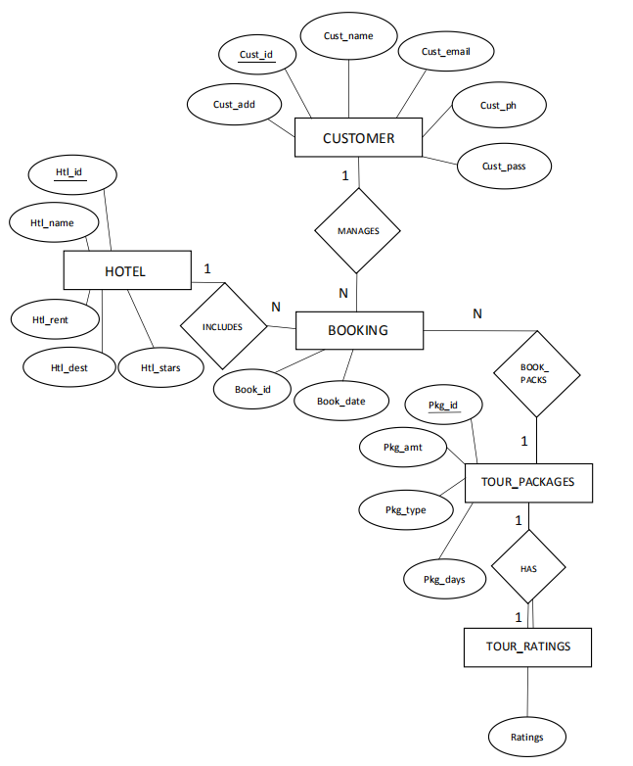

Fig 4.1: E R Diagram of Tourism Management System

**4.2 Schema Diagram**

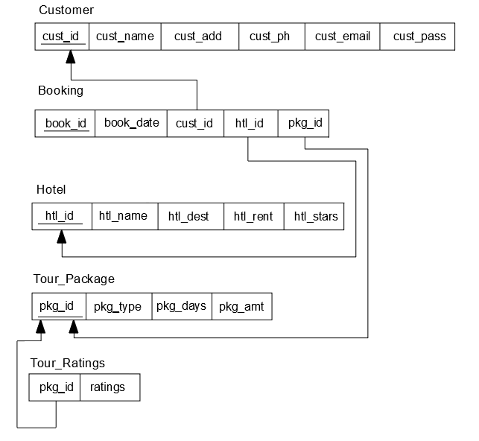

Fig 4.2: Schema Diagram for Tourism Management System

CHAPTER 5

**SYSTEM IMPLEMENTATION**

**5.1 Introduction**

Implementation is the stage of the project when the theoretical design is turned out into a working system. Thus it can be considered to be the most critical stage in achieving a successful new system and in giving the user, confidence that the new system will work and be effective.

The implementation stage involves careful planning, investigation of the existing system and it’s constraints on implementation, designing of methods to achieve changeover and evaluation of changeover methods.

**5.2 Code Snippet**

**create table hotel**(

htl_id integer PRIMARY KEY,

htl_name varchar(30),

htl_dest varchar(30),

htl_rent integer(10),

htl_stars integer);

**create table cust_login**(

cust_id integer PRIMARY KEY AUTO_INCREMENT,

cust_name varchar(20),

cust_add varchar(100),

cust_email varchar(50),

cust_ph integer,

cust_pass varchar(30));

**create table tour_package**(

pkg_id integer PRIMARY KEY AUTO_INCREMENT,

pkg_type varchar(20),

pkg_days integer,

pkg_amt integer);

**create table booking**(

book_id integer PRIMARY KEY,

book_date date,

book_dest varchar(20),

cust_id integer,

pkg_id integer,

htl_id integer,

foreign key(cust_id) references cust_login(cust_id) on delete cascade,

foreign key(pkg_id) references tour_package(pkg_id) on delete cascade,

foreign key(htl_id) references hotel(htl_id) on delete cascade);

**create table** **tour_ratings**(

ratings integer,

pkg_id integer,

foreign key(pkg_id) references tour_package(pkg_id) on delete cascade**);**

**create table admin**(

admin_id integer PRIMARY KEY,

ad_email varchar(20),

ad_pass varchar(20));

**Description of Cust_login table**

|  |  |  |  |  |
| --- | --- | --- | --- | --- |
| Table | Column | Columntype | Length | Constraint |
| CUST_LOGIN | CUST_ID | NUMBER | - | P_KEY |
|  | CUST_NAME | VARCHAR | 30 |  |
|  | CUST_EMAIL | VARCHAR | 30 |  |
|  | CUST_ADD | VARCHAR | 40 |  |
|  | CUST_PH | NUMBER | 20 |  |

**Description of Hotel table**

|  |  |  |  |  |
| --- | --- | --- | --- | --- |
| Table | Column | Column Type | Length | Constraint |
| HOTEL | HTL_ID | NUMBER | - | P_KEY |
|  | HTL_NAME | VARCHAR | 20 |  |
|  | HTL_DEST | VARCHAR | 30 |  |
|  | HTL_RENT | NUMBER | - |  |
|  | HTL_STARS | NUMBER | - |  |

**Description of Tour_package table**

|  |  |  |  |  |
| --- | --- | --- | --- | --- |
| Table | Column | Column Type | Length | Constraint |
| TOUR_PACKAGE | PKG_ID | NUMBER | - | P_KEY |
|  | PKG_TYPE | VARCHAR | 20 |  |
|  | PKG_DAYS | NUMBER | - |  |
|  | PKG_AMT | NUMBER | - |  |

**Description of Booking table**

|  |  |  |  |  |
| --- | --- | --- | --- | --- |
| Table | Column | Columntype | Length | Constraint |
| BOOKING | BOOK_ID | NUMBER | - | P_KEY |
|  | BOOK_DATE | DATE | - |  |
|  | CUST_ID | VARCHAR |  | F_KEY |
|  | PKG_ID | NUMBER | - | F_KEY |
|  | HTL_ID | NUMBER | - | F_KEY |

**Description of Tour_ratings table**

|  |  |  |  |  |
| --- | --- | --- | --- | --- |
| Table | Column | Column Type | Length | Constraint |
| TOUR_RATINGS | PKG_ID | NUMBER | - | F_KEY |
|  | RATINGS | NUMBER | - |  |

**Description of Admin table**

|  |  |  |  |  |
| --- | --- | --- | --- | --- |
| Table | Column | Column Type | Length | Constraint |
| ADMIN | ADMIN_ID | NUMBER | - | P_KEY |
|  | AD_EMAIL | VARCHAR | 20 |  |
|  | AD_PASS | VARCHAR | 20 |  |

**5.3 Insert, Update, Delete,Stored Procedure,Trigger**

**Code snippet for Insert**

$dbserver="localhost";

$dbuser="root";

$dbpassword="";

$dbname="tourism_management";

$con=mysqli_connect($dbserver,$dbuser,$dbpassword,$dbname);

if(isset($_POST['submit']))

{

$type=$_POST['type'];

$days=$_POST['days'];

$amt=$_POST['amt'];

$sql="INSERT INTO tour_package (pkg_type,pkg_days,pkg_amt)values('$type','$days','$amt')";

mysqli_query($con,$sql);

}

**Code snippet for Delete**

if($id=$_GET['id']){

$q1=" DELETE FROM `tour_package` WHERE pkg_id = $id";

mysqli_query($con,$q1);

}

Code snippet for Update

$id=$_GET['id'];

if(isset($_POST['submit']))

{

$amt=$_POST['amt'];

$q = " UPDATE `tour_package` SET `pkg_amt`=$amt where pkg_id=$id";

$query = mysqli_query($con,$q);

}

**Code snippet for Stored Procedure**

$name=$_POST['name'];

$address=$_POST['address'];

$password=$_POST['password'];

$email=$_POST['email'];

$number=$_POST['number'];

$sql="CALL InputData('".$name."','".$address."','".$email."','".$number."','".$password."')";

mysqli_query($con,$sql);

**CREATE PROCEDURE InputData(**

custname varchar(20),

custadd varchar(20),

custemail varchar(20),

custph integer,

custpass varchar(20))

BEGIN

INSERT INTO cust_login(cust_name,cust_add,cust_email,cust_ph,cust_pass) VALUES(custname,custadd,custemail,custph,custpass);

END

**Code snippet for Trigger**

DROP TRIGGER IF EXISTS tr_ins_char;

**CREATE TRIGGER** tr_ins_char

BEFORE INSERT ON cust_login

FOR EACH ROW

SET NEW.cust_name= UPPER(NEW.cust_name);

**CREATE TRIGGER** trigger_del

AFTER DELETE ON tour_package

FOR EACH ROW

INSERT INTO package_del

(pkgid,pkgtype,pkgdays,pkgamt)

VALUES

(OLD.pkg_id,OLD.pkg_type,OLD.pkg_days,OLD.pkg_amt);

CHAPTER 6

**RESULTS AND SNAPSHOTS**

**Snapshot 1: This snapshot shows the main home page.**

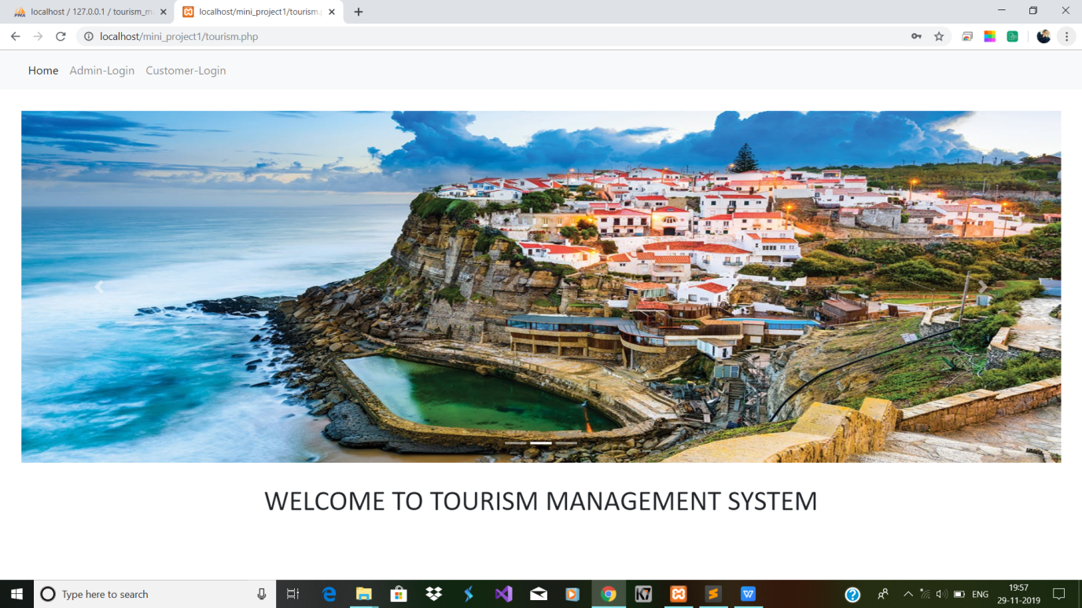

**Snapshot 2: This snapshot shows the login page of the Tourism management system.**

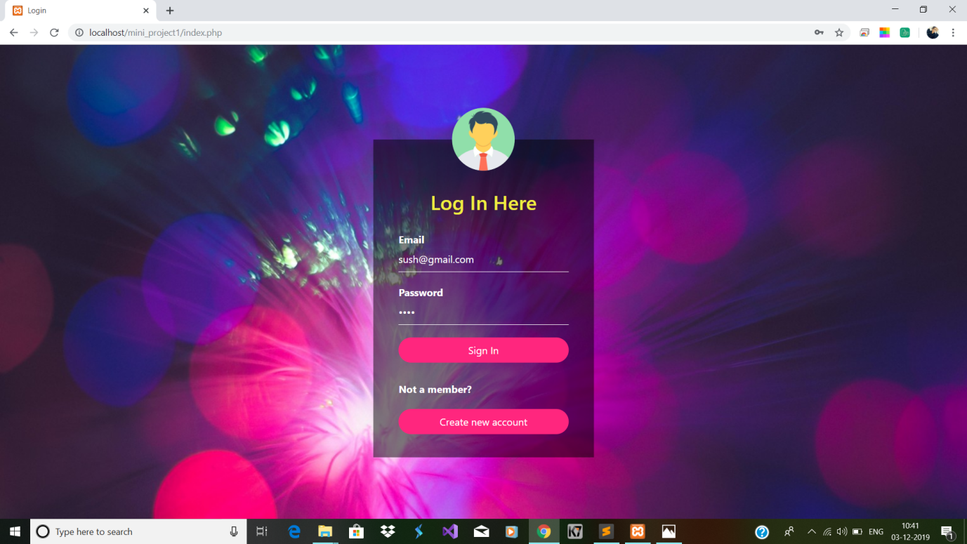

**Snapshot 3:This is the page observed after entering the proper username and password.**

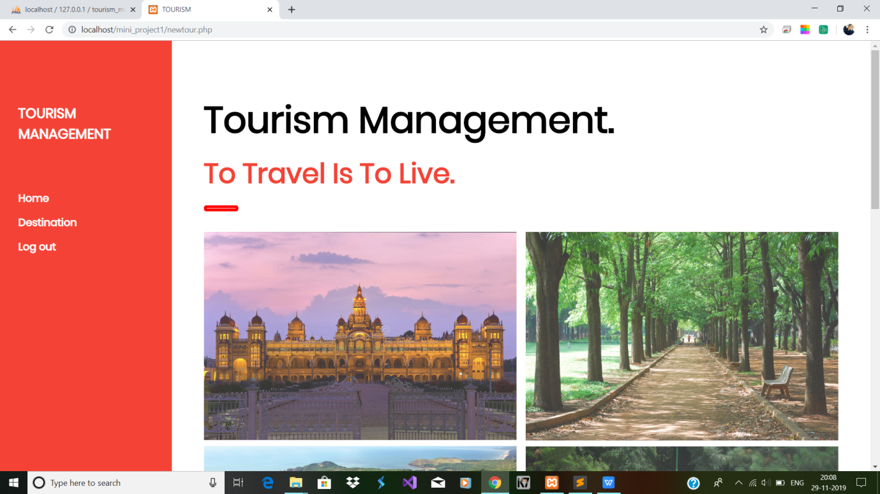

**Snapshot 4: This is a snapshot observed for booking the destination .**

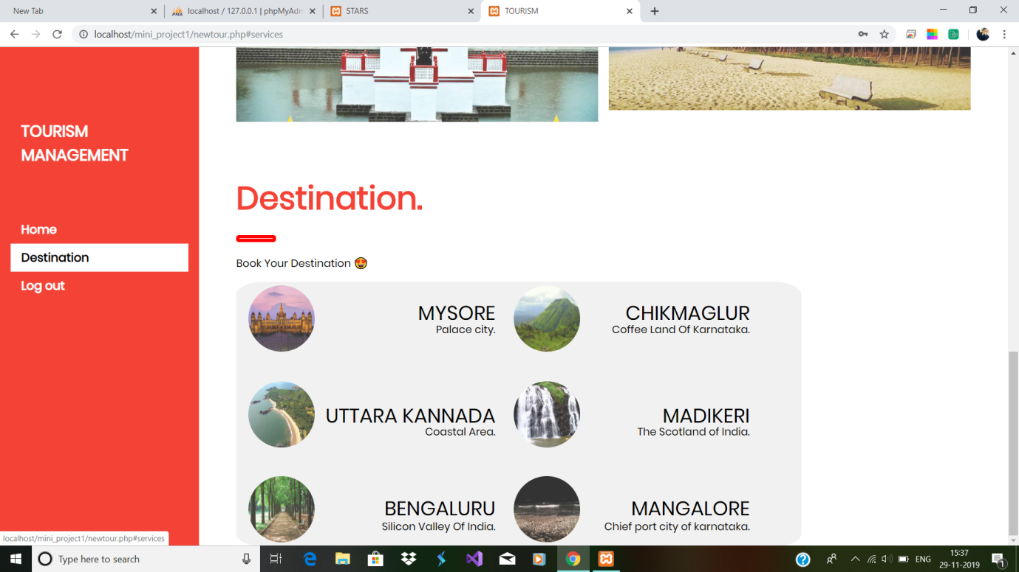

**Snapshot 5: The snapshot of the page to choose booking date and hotel.**

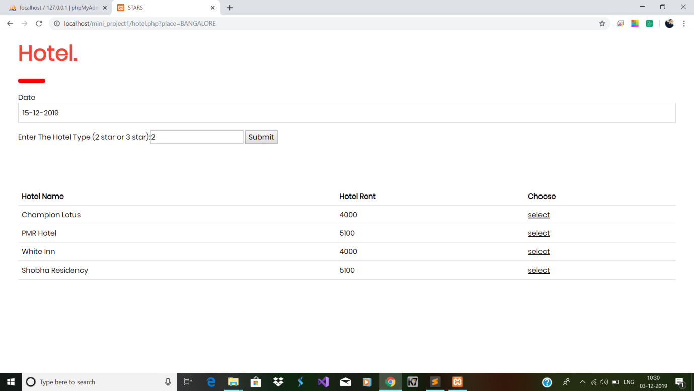

**Snapshot 6: This shows the snapshot of the page to select package after selecting the hotel.**

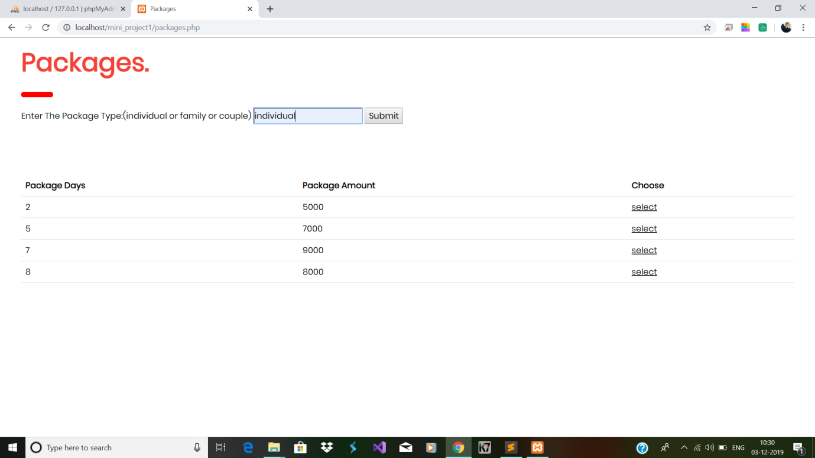

**Snapshot 7: This shows the snapshot of the page to choose customer ratings for the packages available.**

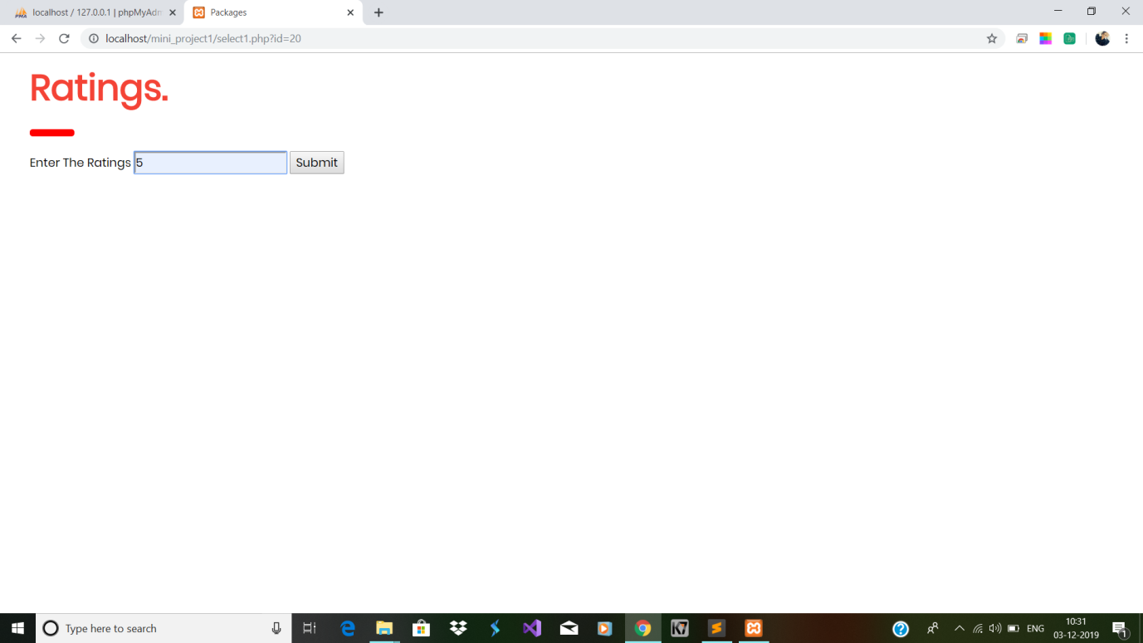

**Snapshot 8: This shows the snapshot of the page indicating that booking is successfull .**

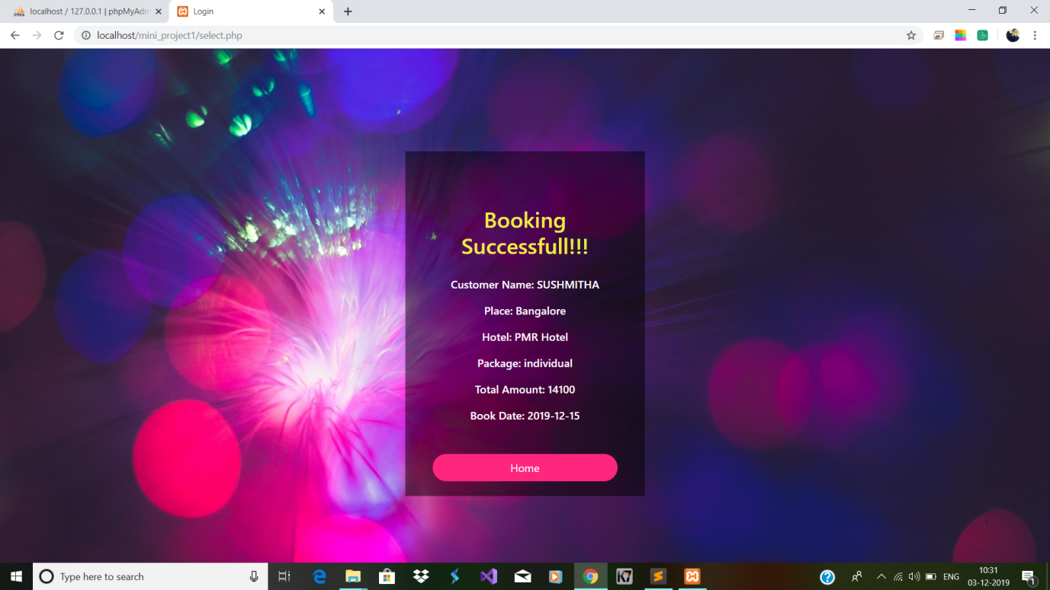

**Snapshot 9: This shows the snapshot of the page designed for admin to perform insert,update,delete packages.**

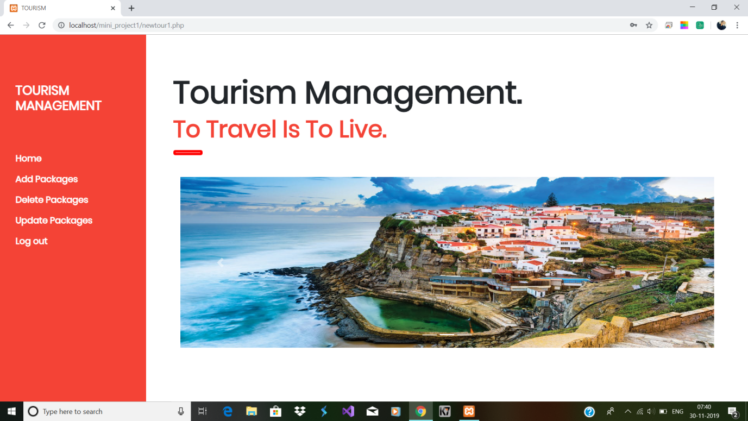

**Snapshot 10: The snapshot of the page for admin to add packages.**

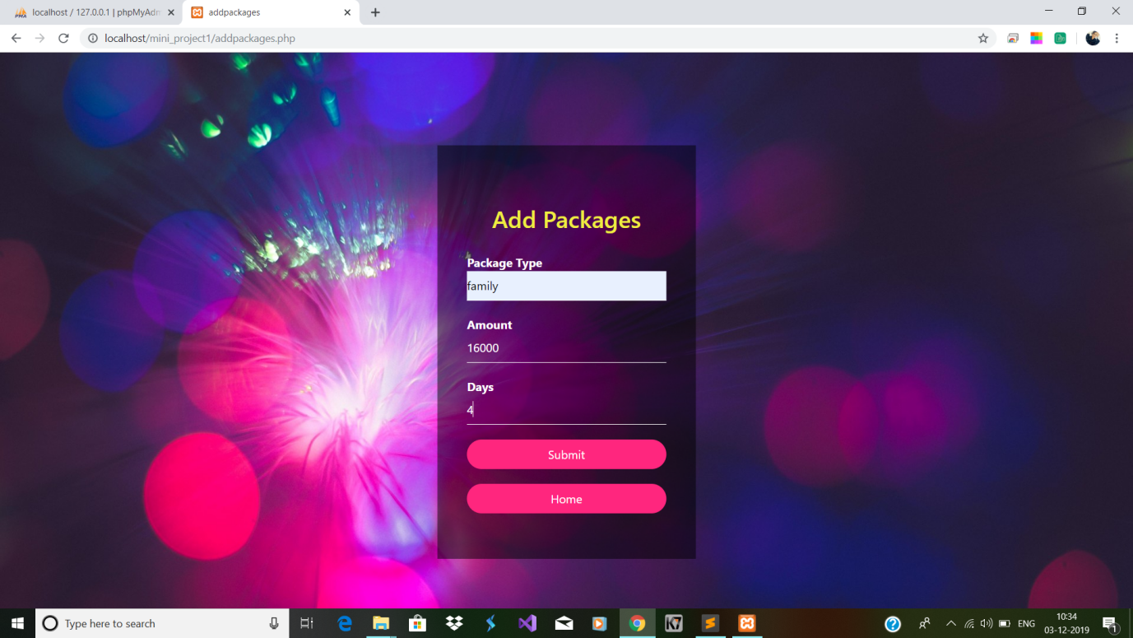

**Snapshot 11: The snapshot of the page for admin to update packages.**

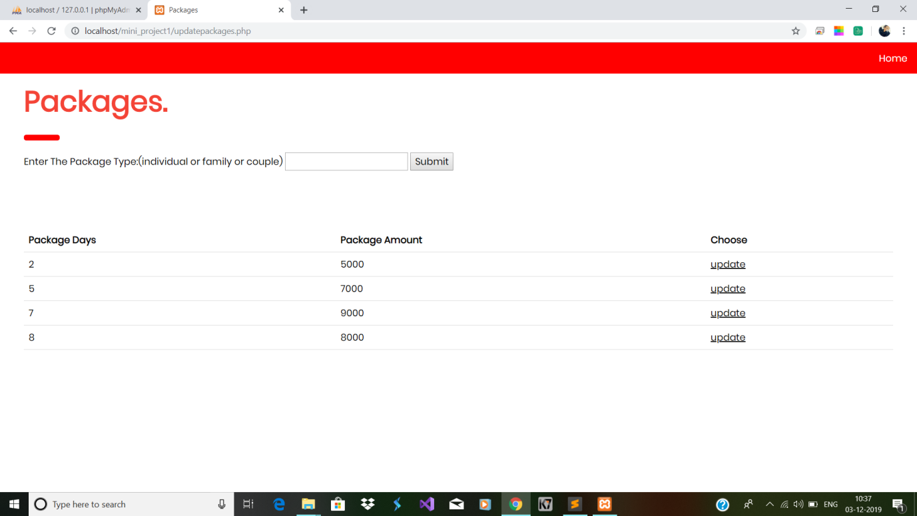

**Snapshot 12: The snapshot of the page for admin to delete packages.**

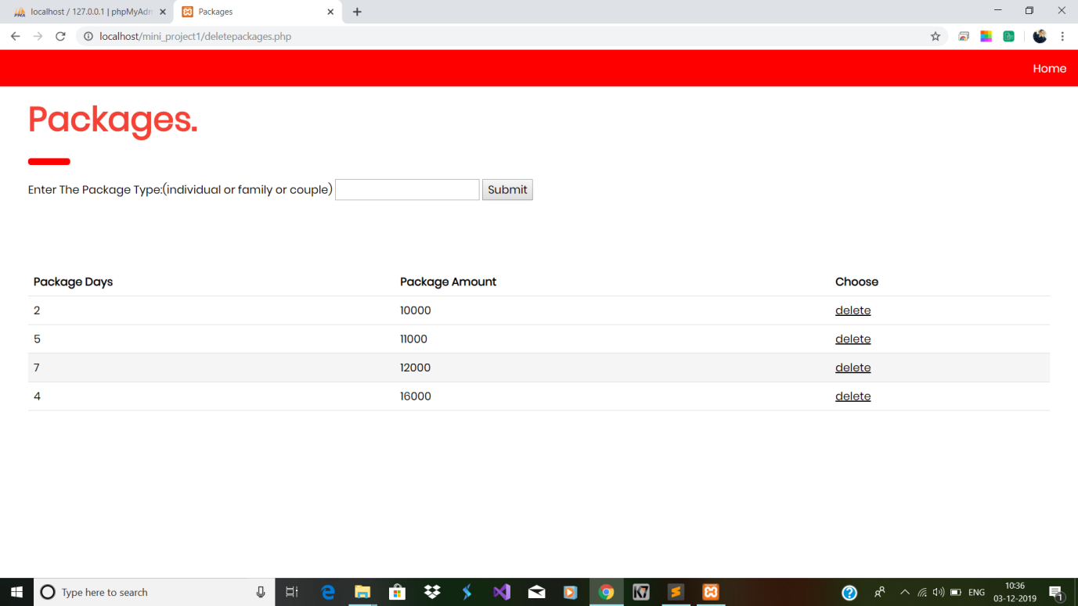

CHAPTER 7

**CONCLUSION AND FUTURE ENHANCEMENT**

**7.1 Conclusion**

Since we are entering details of the customers electronically in the “Tourism Management System”, data will be secured. Using this application we can retrieve tourist place’s details,hotel details, package details with a single click. Thus processing information will be faster. It guarantees accurate maintenance of details. It easily reduces the book keeping task and thus reduces the human effort and increases accuracy speed.

The overall intention is to automate business processes, manage data, and make your work easier with custom applications. Using database application, this is an attempt to enhance the previous models of manually recording and add functionality of database to it.

**7.2 Future Enhancement and Scope**

In the future enhancements of this project entitled “Tourism management system”, we would like to include facilities like,

1. Providing travel arrangemets.
2. Making it as online system.
3. Providing wider range of tourist places to visit.

**REFERENCES**

[1] Database system Models, Languages, Design, and Application Programming, Ramez Elmasri and Sham Kant b. Navathe, 7th Edition, 2017, Pearson.

[2] https://www.w3schools.com/html

[3] https://www.w3schools.com/css

[4] https://www.w3schools.com/php

[5] https://www.youtube.com